

Software Development

*// Those who can, code. – Des Hardy*

Daniel Ferguson

Software Development SAT

Table of Contents

2 Design Brief 3

2.1 Audience 3

2.2 User Characteristics 3

3 Scope 4

3.1 Items within scope 4

Output 4

Input 4

Processing 4

3.2 Operating Environment 5

Hardware Platform 5

Operating System & Version 5

UI 5

UX 5

Network 5

4 Data Collection 5

4.1 Clients 5

4.2 Functional Requirements 10

4.3 Non Functional Requirements 11

4.4 Constraints 11

Economic 11

Technical 11

Legal Requirements 11

Usefulness 12

Ease of Use 12

5 Use Case Diagram 13

6 Data Flow 14

6.1 Context Diagram 14

6.2 Data Flow Diagram 14

# Design Brief

APA referencing can hinder a student’s performance while writing their case studies, reports and work through the process of referencing, causing the student to loose focus. This has the possibility for students to loose marks. If the student doesn’t correctly reference the work of others, or doesn’t reference the correct source — this can lead to a reduction of marks.

A program that reduces the likelihood of students loosing marks – mainly, a program that gives students the tools to have the best possibility of attaining the marks they deserve for their work. This will be through a program that minimises loss of focus, correct formatting and accreditation reminders.

## Audience

This document is intended for developers, testers, project managers and further documentation writers.

## User Characteristics

Typical / intended user: ***Tertiary Students***

**Frequency of Use**

*Multiple times a year, used frequently / often during those time.*

**Technical expertise**

*Has a moderate understanding of how to use Windows 10.*

**Education Level**

*Completed Secondary School.*

**Experience**

*Moderate skills for referencing and documentation.*

Typical / intended user: ***Secondary Students & Post-Grad Students***

**Frequency of Use**

*Once or twice, not used frequently during those times.*

**Technical expertise**

*Has a moderate understanding of how to use Windows 10.*

**Education Level**

*Completed Year 10, studying VCE or equivalent.*

**Experience**

*Lack of skills in referencing and documentation.*

# Scope

## Items within scope

### Output

*This program will output pastable information about referencing. After the user has filled in the correct information into the CSV template, the program will output said information in the correct formatting for the user to apply to his/her work.  
The program, along with the correctly formatted referencing material, show the relevant information – which the user can apply to their work.*

### Input

*The user’s internet based research, done inside the solution/program on the internal internet web browser, will be the information the program needs to start its main process/purpose. When the user has found information they deem to be useful to their paper/project, they will copy the information. This information will be inserted into a CSV table.*

### Processing

*The user’s will be able to use the solution/program to conduct internet based research, performed on the internal internet web browser.  
Copied information, information that the user has deemed useable and relevant, will be inserted into a CSV table.  
The user will then choose which formatting applies to the copied information, and if there is already an existing table, it will be inserted into that table. If there isn’t a table present with that formatting, a new CSV table will be created and the information will be inserted into the new table.  
The program, when prompted by the user to output referencing information, will then need to stylize the referencing data into a pastable text block for the use to copy and paste/use in their documents.*

## Operating Environment

### Hardware Platform

The program/solution will be built, intended to run on a computer with at least:  
 *- 2GB RAM  
 - Core i3 Processor (1.6GHz)  
 - 5Gb Free Hard Drive Space*

### Operating System & Version

*The program/solution is aimed for using on the Windows Operating System, compatible with versions of Windows 7, 8, 8.1 and 10.*

### UI

The user interface needs to be clear and concise, as to be easily understandable.

### UX

The user should have a rewarding experience, and want to use the program again because it has helped them achieve their goal, more effectively and efficiently than other methods.

### Network

There must be a connection to the internet for the program/solution to be usable.

# Data Collection

Because I want to scope this application to University students, I think it would be best to choose a couple of first year students, second year students and third year students.

## Clients (University Students)

**Tahlia Bruce**

“I have a problem with referencing as it is a tedious, time consuming component of assessment papers, that is confusing and can often take more time than the actual assessment itself. I believe that a program that can record and format references for students would be a time saver, allowing students to put more time and effort into their assessments.”

**Senni Turner**

Do you enjoy referencing? Why/Why not?

“I don't really enjoy referencing at all. I think Harvard referencing is informative but tedious to do.”

Do you get distracted from your work by having to do referencing?

“I write basic information down on sources while I'm writing my papers and I do referencing at the end.”

If not, please share any ways you think referencing could become easier…

“I don't really know how it could be easier.”

Would a system that automatically saves where you copied information from help you? Why/Why not?

“It definitely would help because it would save a lot of time and then I can just tweak the referencing at the end of my research.”

**Olivia Delecheneau**

Do you enjoy referencing? Why/Why not?

“Yes, it's an easy to follow method and it makes it easier for everyone to understand.”

Do you get distracted from your work by having to do referencing?

“No, it keeps me in track and I will know where I got all of my info from in case I need to go back and double check.”

Would a system that automatically saves where you copied information from help you? Why/Why not?

“It would help because then it would make it a lot easier, just in case you happen to forget to jot down the reference.”

**Georgia Vance**

Do you enjoy referencing? Why/Why not?

“I don't enjoy it because it is time consuming.”

Do you get distracted from your work by having to do referencing?

“Yes, I suppose I do because it can take up to two hours to draft a bibliography.”

Would a system that automatically saves where you copied information from help you? Why/Why not?

“Yes, it would.”

**Nicholas Dharumasena**

Do you enjoy referencing? Why/Why not?

“…it's good and easy to learn and use when needing to go through a lot of references.”

Do you get distracted from your work by having to do referencing?

“Yeah it does get a bit distracting because I have to spend more time trying to get work done. And it can take more time trying to get work done.”

Would a system that automatically saves where you copied information from help you? Why/Why not?

“Yes, I would be interested in a program that does that.”

**Harrison Pickford**

Do you enjoy referencing? Why/Why not?

“I don’t mind it, but it takes a long time to do and having to list everything can also effect word count on a assignment.”

Do you get distracted from your work by having to do referencing?

“Yes I do, as I have to take a look at things that do not directly relate to my work.”

Would a system that automatically saves where you copied information from help you? Why/Why not?

“Yes, I would if it can cut time off having to find all the information about a book or article.”

## Clients (High School Students)

**Brandon Moss**

Do you have to do much referencing in High School?

“No, teachers keep telling me to though.”

Does referencing get in the way of your workflow? / Does it distract you from your work? / Does it make you lose focus?

“Yes. I really dislike referencing, and that’s why I’m doing this.”

In your opinion, what would a program to help you need to do to make it effective in helping you reference your work?

“I can’t think of something more helpful.”

**Finn Clark**

Do you have to do much referencing in High School?

“For most of my English and Phycology task I reference, but not a lot for the rest of my subjects – but I am well aware that I will be in university.”

Does referencing get in the way of your workflow? / Does it distract you from your work? / Does it make you lose focus?

“Yes, it’s a terrible distraction.”

In your opinion, what would a program to help you need to do to make it effective in helping you reference your work?

“Yes.”

**Liam Gooch**

Do you have to do much referencing in High School?

“No, but I know that I will need to start to practise for University”

Does referencing get in the way of your workflow? / Does it distract you from your work? / Does it make you lose focus?

“I don’t really know yet, as I do not do too much referencing – it’s too difficult to figure out.”

In your opinion, what would a program to help you need to do to make it effective in helping you reference your work?

“Most certainly - I find it too difficult to start the referencing project because I don’t really know how to do it. It would be great to have a program that did it on the go so I don’t take time out of doing my work to get it done. This program would be a huge help and would allow me to get it all done in time and in the most efficient way.”

## Functional Requirements

|  |  |  |
| --- | --- | --- |
| ***Sequence #*** | ***Description*** | ***Comments*** |
| FR01 | Web Browsing Capabilities | *Because the software is centred around the notion that research will be done on the internet, the user will need to ability to browse the internet just as if they were using a different web browser.* |
| FR02 | CSV Tables | *Users need to be able to input information into the CSV table for later referencing in project, research papers, etc.*  *To help ensure data loss is at a minimum, users should be able to save the CSV tables as program ‘sessions’. They should also be able to open ‘sessions’ to continue their work.*  *Users should have the capability to search the CSV tables. This search function should also be able to handle errors, and alert the user.*  *The CSV table should be editable, so that if a user makes an error when inputting, they can correct it later.*  *Users should be able to create new CSV tables, with different column headings for the different requirements needed for specific referencing (e.g. PDF referencing differs from website referencing). Users should also be able to create new rows in each CSV table as needed.* |
| FR03 | Page Navigation | *To make the program more intuitive, the program should be sectioned up into two windows / interfaces. The user should be able to switch between the windows fast and intuitively.* |
| FR04 | System.IO | *To trigger information notifications, the program will need to be able to determine when* ***changes to the system’s clipboard*** *occur. This will be the trigger for the program to alert the user and give the option to input reference data straight away. This notification can also be ignored, and also turned off in a settings window/file.* |
| FR05 | Data Protection | *The program should auto save sessions in the background to help prevent accidental data loss. Saving the Sessions with a readable, usable format (such as Title, Date, Time) will also be important to prevention.* |

Functional Requirements Table

## Non Functional Requirements

|  |  |  |
| --- | --- | --- |
| ***Sequence #*** | ***Description*** | ***Comments*** |
| NFR01 | Ease of Use | *The program will need to be easy to use – it shouldn’t be hard to learn, nor difficult or time consuming to use. A user should be able to open the software and instantly have an understanding of its basic functionality, and how it functions.* |
| NFR02 | Reliability | *Because the program will be containing sensitive and crucial information, the program will need to be as stable as possible. It may also have background functions to help ensure this – like an AutoSaving feature to ensure crucial data isn’t lost.* |
| NFR03 | Maintainability | *The program should have a LSV stamp; meaning a Long-standing Service Version. As mentioned above, the software shouldn’t have to have constant updates; but if it does, it should be backwards compatible with previous saves from past software versions.* |
| NFR04 | Portability | *In case of a sudden breakthrough with technology while the software is being developed, the software should be as modular as possible. This will speed up the process if the process of porting is necessary. It would also help speed up development, being able to focus on specific tasks at a time.* |

Non Functional Requirements Table

## Constraints

### Economic

This project has no funding. This will mean that I cannot outsource anything, use external commercial frameworks, etc.

### Technical

Users may not have a powerful machine (CPU of > Intel Celeron) or large portion of space of their Hard Drive (>500MB). Users of this program will also be running Windows (Windows OS 7 to Windows 10). Something to design for are users that only have a laptop/tablet (Trackpad, no mouse - also may mean touchscreen only).

### Legal Requirements

As this is freeware, and open source software, I don’t have any legal obligations. This is also because I am not collecting any personal information, I don’t have any privacy laws that I need to adhere to.

### Usefulness

The software will need to help the user to reference either more quickly, or later more reliably. This is also how I will evaluate the effectiveness of the software later on.

### Ease of Use

The software will need to be basic, intuitive and easy to use. Users should be able to start the software and be walked through it, or have an option to be tutored (in some form) of how to use the software. This can be through a video or an interactive piece of software over the original screen.

# Use Case Diagram

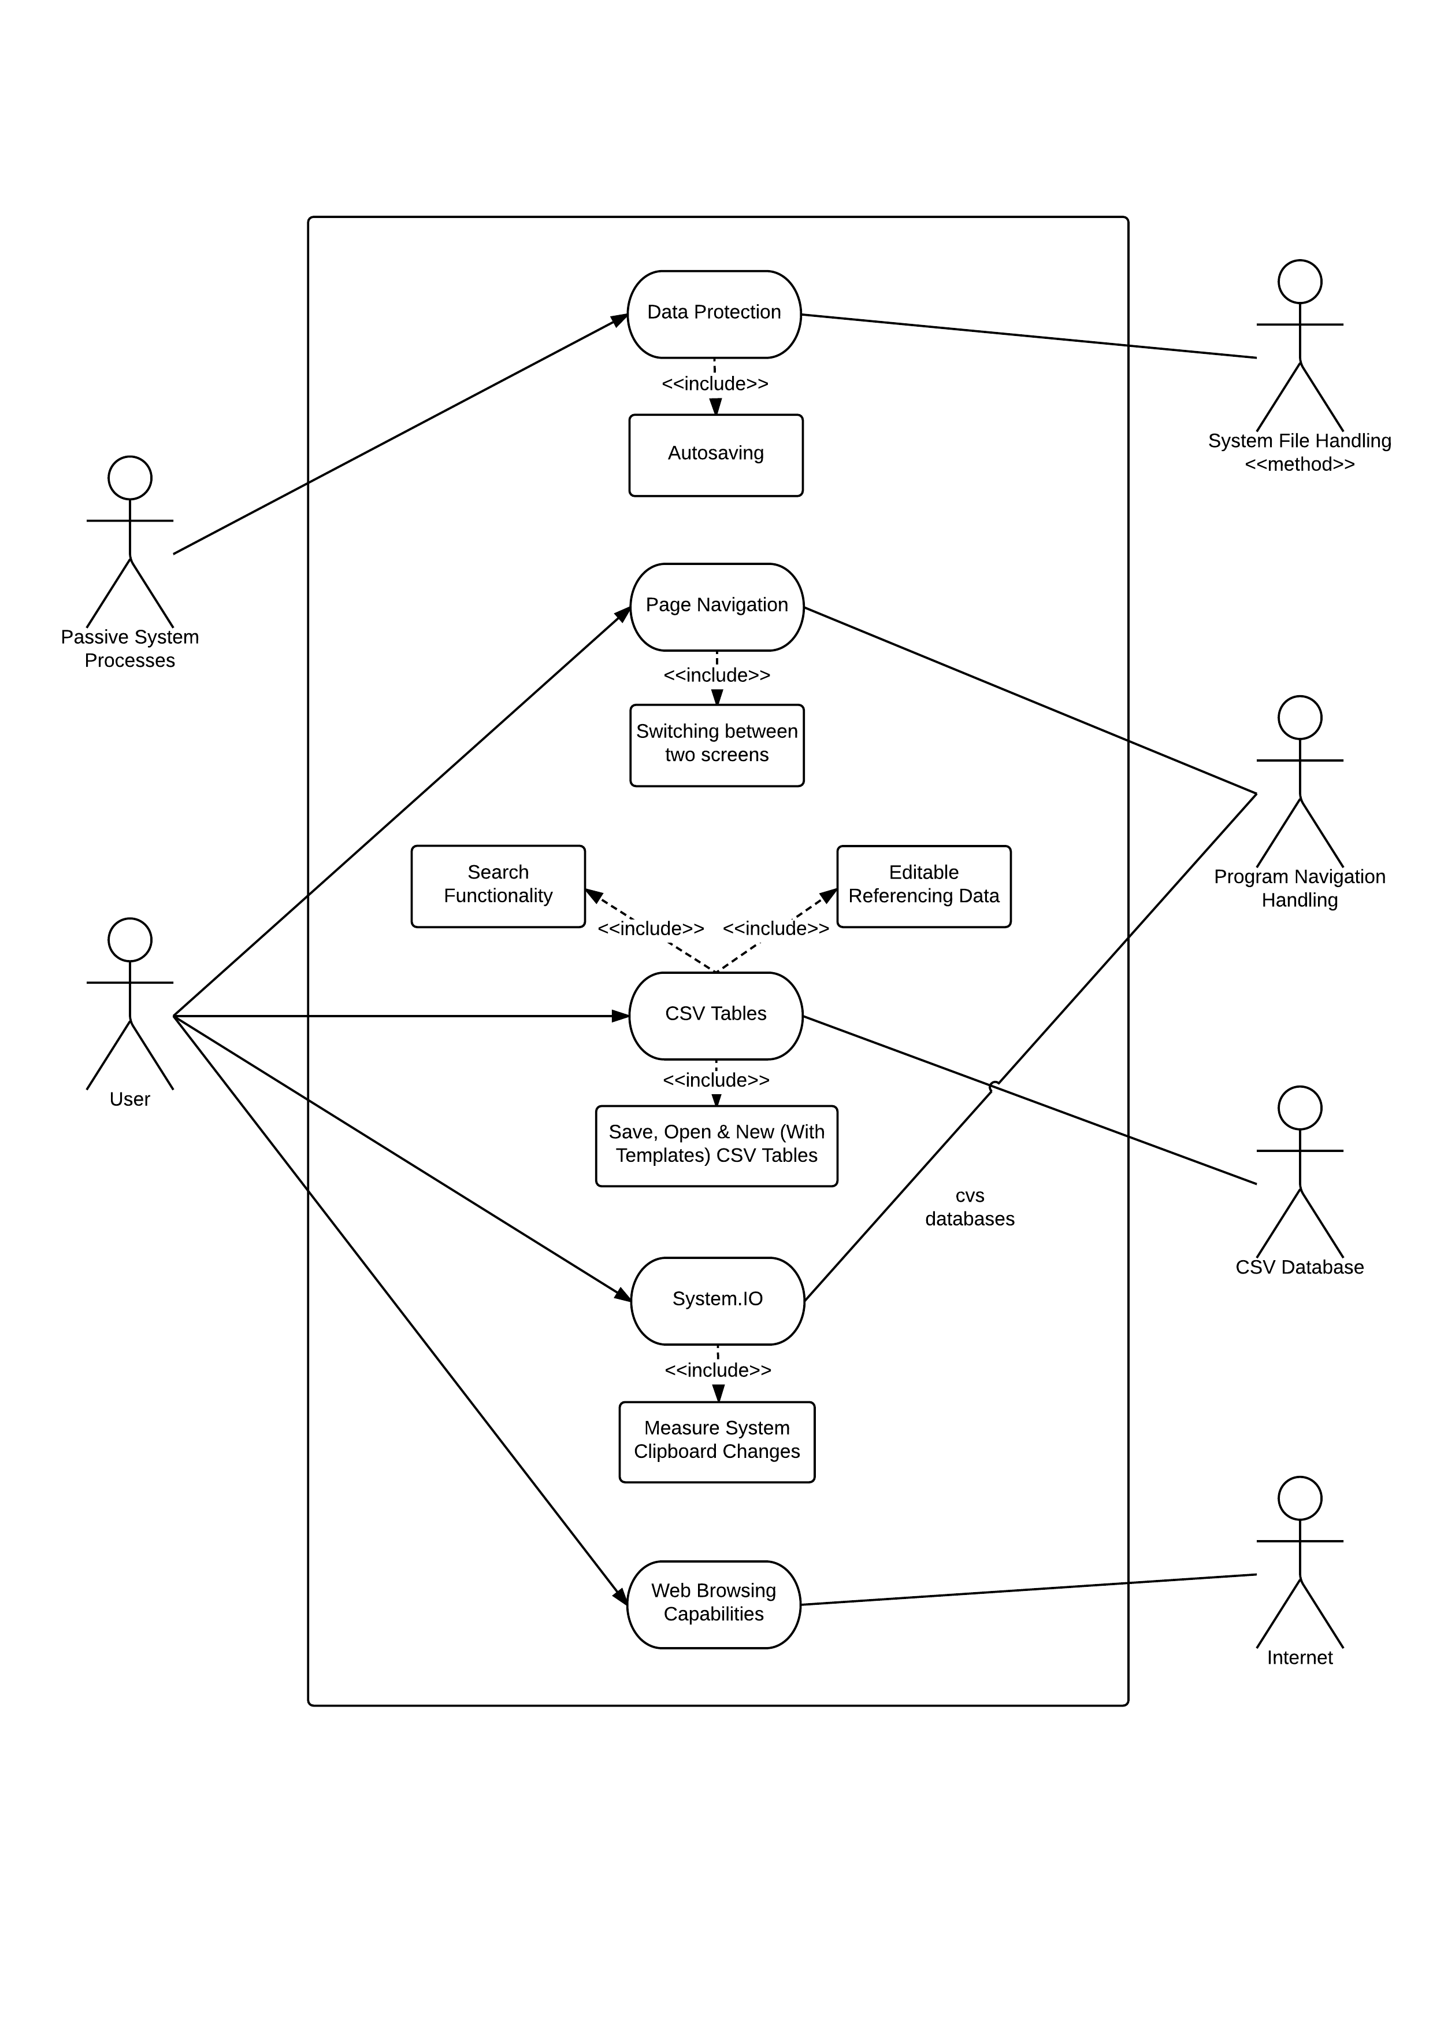

# Data Flow

## Context Diagram

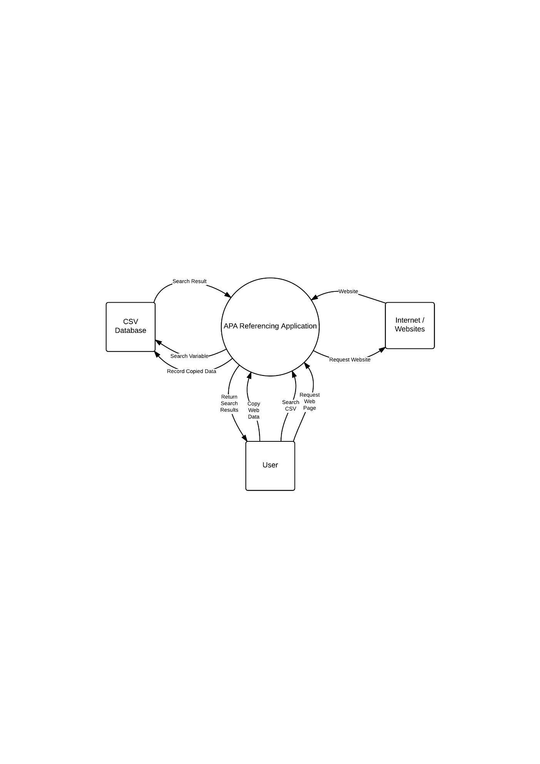

## ../../../../../Downloads/CD%20&%20DFD%20-%20Data%20Flow%20DiagraData Flow Diagram